New Features of Excel 2013

Open the Excel2013Demo workbook to explore these new features of Excel 2013.

Flash Fill

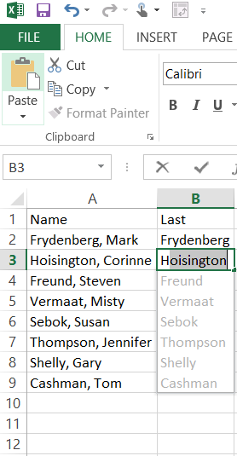
Flash Fill enters your data, following patterns it recognizes.

On the Flash Fill sheet, type Frydenberg in cell B2, and enter the H of Hoisington in cell B3. What happens?
What other values can you flash fill? Try first name, initials, last name comma first initial, etc.
What happens if you type a new person’s name in cell A10?
How might you accomplish this task in earlier versions of Excel?

Instant data analysis
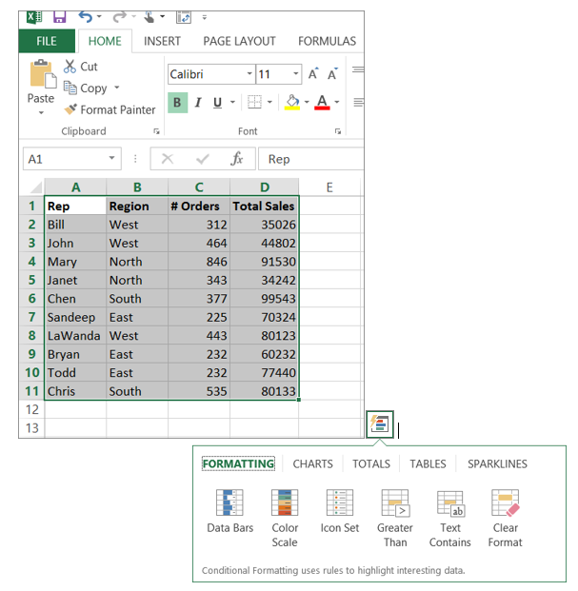
The Quick Analysis tool converts your data into a chart or table in few steps. Preview your data with conditional formatting, sparklines, or charts, and make your choice stick in just one click.
Select the Data Analysis worksheet.
Select the range A1:D11. Hover over the options for charts, totals, tables, and sparklines. Create databars, appropriate charts and tables for the data.

Recommended Charts
With Chart recommendations, Excel recommends the most suitable charts for your data. Preview how your data looks in the different charts.
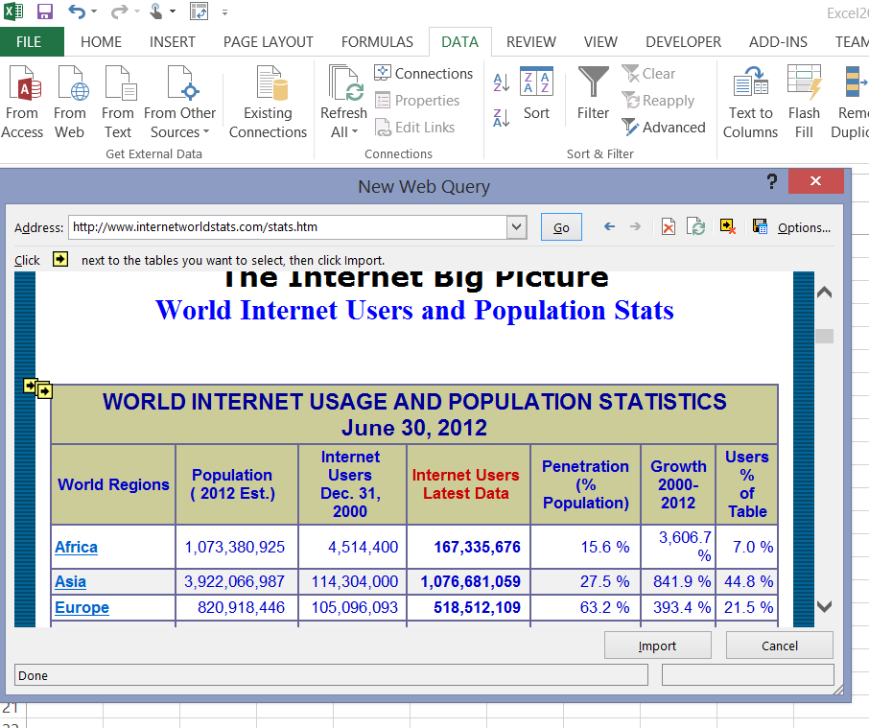
Select the Charts worksheet.
Use Data From Web to import the data from http://www.internetworldstats.com/stats.htm and place it in cell A1.
Select the data in range A5:D:11 (don’t include the total row!)
Insert Recommended Charts, and see what recommendations that Excel gives.
Select A5:B11 (only one column of data) – does Excel give you a different set of chart recommendations?

Filter table data using slicers
First introduced in Excel 2010 as an interactive way to filter PivotTable data, slicers can now also filter data in Excel tables, query tables, and other data tables.
On the Slicer worksheet, insert a table to contain the data shown.
Insert a slicer on the Regions column. How are slicers and filters related?
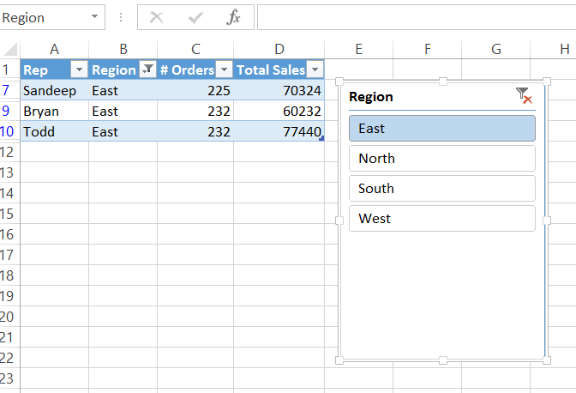

One workbook, one window
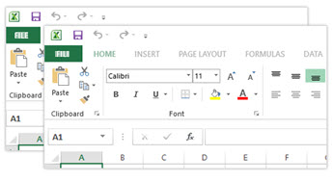
In Excel 2013 each workbook has in its own window, making it easier to work on two workbooks at once. It also makes life easier when you’re working on two monitors.
Open another copy of Excel. Place two Excel windows side by side.
How nice is that?

Recommended Pivot Tables
Create a pivot table from data on the Data Analysis sheet, and place the pivot table on the existing sheet called Pivot, in cell A1.
Use the recommended Pivot Tables feature to determine recommended pivot tables based on the data that you have selected.
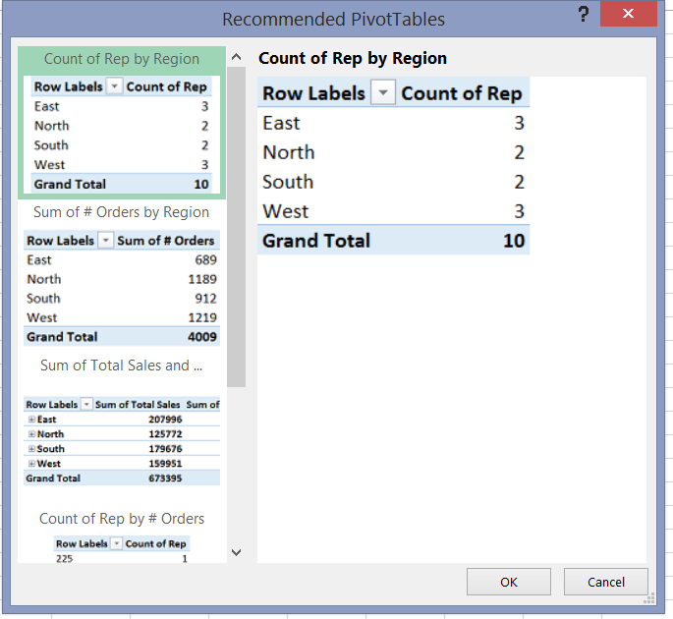

Apps for Office

Select the Apps worksheet.
Insert the Bing Maps for Office app from the Office App Store (Insert Apps for Office -> Bing Maps) and click on the insert sample data option to get a sense of how this app works.
Create or find another set of data to map using this app.
